**HTTP Basic**

*What is* HTTP*?*

* Hyper Text Transfer Protocol
* Responsible for communication between Web Server and Clients
* HTTP Request and Response (Like Loading a page, form submission)
* Every HTTP request is completely independent (Each request is like a single transaction)
* For Enhancing user experience its uses
  + Programming
  + Local Storage
  + Cookies
  + Session

*What* is HTTPs?

* Hyper Text Transfer Protocol **Secure**
* Data sent is encrypted using SSL (Secure Socket Layer) or TLS (Transport Layer
* Used for system like credit card data, social security

HTTP Methods (Request Methods)

* **GET**
  + Retrieves or fetch data from server
  + Example: loading html file, CSS files, json data, xml data
  + Every time visit a website you making a GET request to server
* **POST**
  + Posting/adding/submitting data to server
  + When you submit a form, making a post request to server
  + Sending data to server
* **PUT**
  + Update data already on the server
* **DELETE** 
  + Delete data from the server

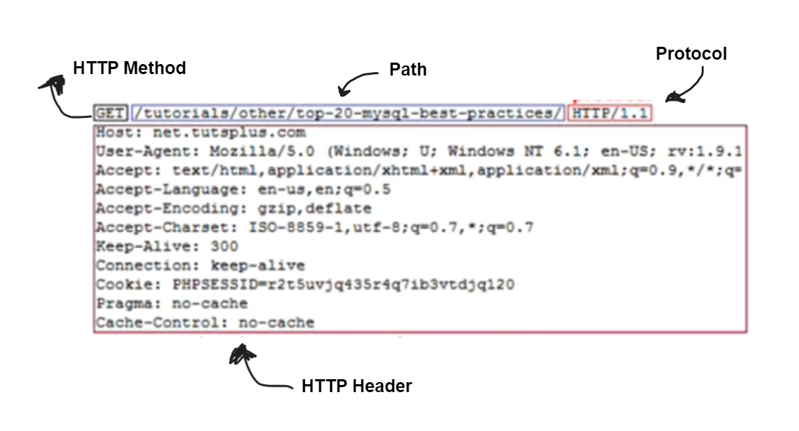



HTTP Header Files

* **General Header**
  + Request URL
  + Request Method
  + Status Code
  + Remote Address
  + Referrer Policy
* **Response Header**
  + Server
  + Set-Cookie
    - Set Small piece of data to server client
    - This header is used to send a cookie from the server to the user agent, so that the user agent can send it back to the server later.
  + Content-Type
  + Content- Length
  + Date
* **Request Methods**
  + Cookies
    - The Cookie HTTP request header contains stored HTTP cookies associated with the server (i.e., previously sent by the server with the Set-Cookie header)
    - An HTTP cookie (web cookie, browser cookie) is a small piece of data that a server sends to a user's web browser. The browser may store the cookie and send it back to the same server with later requests
  + Accept-xxx
  + Content-Type
  + Content-Length
  + Authorization
  + User-Agent
    - The User-Agent request header is a characteristic string that lets servers and network peers identify the application, operating system, vendor, and/or version of the requesting user.
    - *User-agent: Mozilla/5.0 (Linux; Android 6.0; Nexus 5 Build/MRA58N) AppleWebKit/537.36 (KHTML, like Gecko) Chrome/110.0.0.0 Mobile Safari/537.36 Edg/110.0.1587.57*
  + Referrer

Sample HTTP Header

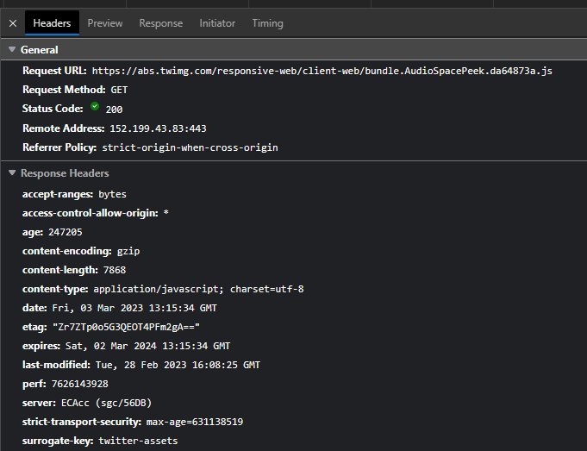

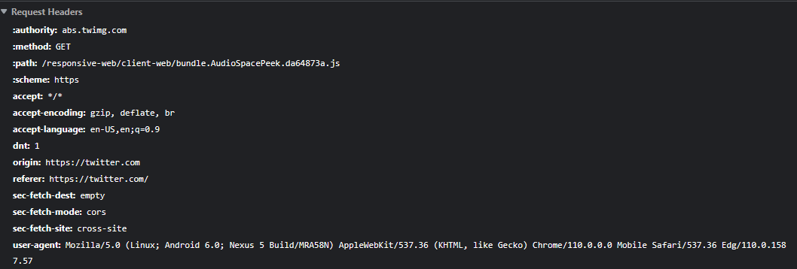

HTTP Status Code

An HTTP status code is a server response to a browser's request. When you visit a website, your browser sends a request to the site's server, and the server then responds to the browser's request with a three-digit code: the HTTP status codes are:

* **1XX: Informational**
  + Request received or processing continue
* **2XX: Success**
  + Successfully received / understood and accepted
  + Example:
    - *200 – OK*
    - *201 – OK Created*
* **3XX: Redirect** 
  + Further action must be taken
  + Example:
    - *301 – Moved to new URL*
    - *304 – Not Modified (Cached Version)*
* **4XX: Client Error**
  + Request does not have what it needs for client
  + Example:
    - *400 – Bad Request*
    - *401 – Unauthorized*
    - *404 – Not Found*
* **5XX: Server Error**
  + Server Failed to fulfill an apparent valid request
  + Example:
    - *500 – Internal Server Error*



